Wood End Primary School



**Anti-Bullying Policy**

|  |  |  |
| --- | --- | --- |
| **Written by: M Cross** |  | **Date:** March 2023 |
| **Date for review:** | March 2024 | |
| **Approved by governors:** | 27th March 2023 | |

**Wood End Primary School**

**Anti-Bullying Policy**

**At Wood End School Every Child Matters.**

1 Introduction

It is a Government requirement that all schools have an anti-bullying policy. The Academy policy reflects this and recent DfE advice.

DfE guidance defines bullying as actions that are meant to be hurtful, and which happen on a regular basis. Bullying can be direct (either physical or verbal) or indirect (for example, being ignored or not spoken to).

2 Aims and objectives

Bullying is wrong and damages individual children. We therefore do all we can to prevent it, by developing a school ethos in which bullying is regarded as completely unacceptable.

We aim, as a school, to produce a safe and secure environment where all can learn without anxiety, and measures are in place to reduce the likelihood of bullying.

This policy aims to produce a consistent school response to any bullying incidents that may occur.

We aim to make all those connected with the school aware of our opposition to bullying, and we make clear each person’s responsibilities with regard to the eradication of bullying in our school.

3 The role of governors

The School Standards Committee (SSC) supports the Executive Headteacher in all attempts to eliminate bullying from our school. The SSC will not condone any bullying at all in our school, and any incidents of bullying that do occur will be taken very seriously, and dealt with appropriately.

The SSC monitors incidents of bullying that do occur, and reviews the effectiveness of this policy regularly. The governors require the Executive Headteacher to keep accurate records of all incidents of bullying, and to report to the governors on a termly basis about the effectiveness of school anti-bullying strategies.

A parent who is dissatisfied with the way the school has dealt with a bullying incident can ask the chair of governors to look into the matter. The governing body responds within ten days to any request from a parent to investigate incidents of bullying. In all cases the governing body notifies the Executive Headteacher, and asks him/her to conduct an investigation into the case- this may be delegated to the Associate Head, and to report back to a representative of the governing body. The governing body then report their findings to the parent.

4 The role of the Executive Headteacher

It is the responsibility of the Executive Headteacher to implement the school anti-bullying strategy, and to ensure that all staff (both teaching and non-teaching) are aware of the school policy, and know how to identify and deal with incidents of bullying. The Executive Headteacher reports to the SSC about the effectiveness of the anti-bullying policy on request. The anti-bullying policy will usually form part of the induction process for new staff.

The Executive Headteacher ensures that all children know that bullying is wrong, and that it is unacceptable behaviour in this school. The Executive Headteacher draws the attention of children to this fact at suitable moments. For example, if an incident occurs, the Executive Headteacher may decide to use an assembly as the forum in which to discuss with other children why this behaviour was wrong, and why a pupil is receiving a logical consequence.

The Executive Headteacher ensures that all staff, including lunchtime staff, receive sufficient training to be equipped to identify and deal with all incidents of bullying.

The Executive Headteacher sets the school climate of mutual support and praise for success, so making bullying less likely. When children feel they are important and belong to a friendly and welcoming school, bullying is far less likely to be part of their behaviour.

5 The role of the Associate Headteacher

It is the responsibility of the Associate Headteacher to support the Executive Headteacher in the implementation of the school anti-bullying strategy, on a day to day basis, and know how to identify and deal with incidents of bullying. The Associate Headteacher provides ongoing information to the Executive Headteacher about incidents which are then used to report to the SSC.

The Executive Headteacher ensures that all children know that bullying is wrong, and that it is unacceptable behaviour in this school. The Associate Headteacher draws the attention of children to this fact at suitable moments. For example, if an incident occurs, the Associate Headteacher may decide to use an assembly as the forum in which to discuss with other children why this behaviour was wrong, and why a pupil is receiving a logical consequence.

6 The role of the teacher and support staff

All the staff in our school take all forms of bullying seriously, and seek to prevent it from taking place.

If teachers witness an act of bullying, they will investigate it themselves and always refer it to the Associate Headteacher. Teachers and support staff do all they can to support the child who is being bullied. If a child is being bullied over a period of time, then, after consultation with the Executive/ Associate Headteacher, the teacher informs the child’s parents.

The school uses CPOMS an online system on which staff record all incidents of bullying that occur both in and out of class. We also record incidents that occur near the school, or on the children’s way between school and home. Any adult who witness an act of bullying should record it on CPOMS using the bullying/ friendship issues tag.

When any bullying takes place between members of a class, the teacher will deal with the issue immediately. This may involve counselling and support for the victim of the bullying, and consequences for the child who has carried out the bullying. Time is spent talking to the child who has bullied: explaining why his/her action was wrong, and that child is encouraged to change his/her behaviour in future. If both parties agree, there will be a restorative conversation facilitated by a member of staff in line with the school’s Relational Policy.

If a child is repeatedly involved in bullying other children, staff inform the Executive Headteacher and the SENDCO. We then invite the child’s parents into the school to discuss the situation. In more extreme cases, for example where these initial discussions have proven ineffective, Executive/ Associate Headteacher may contact external support agencies, such as Children’s services.

All members of staff routinely attend training, which equips them to identify bullying and to follow school policy and procedures with regard to behaviour management.

Teachers use a range of methods to help prevent bullying and to establish a climate of trust and respect for all. They use drama, assemblies, role-play, stories etc., within the formal curriculum, to help pupils understand the feelings of bullied children, and to practise the restraint required to avoid lapsing into bullying behaviour. PSHE lessons are an important time in which to learn about bullying. Time is taken in class and as a school to praise, reward and celebrate the success of all children, and thus to help create a positive atmosphere.

7 The role of parents

Parents who are concerned that their child might be being bullied or who suspect that their child may be the perpetrator of bullying, should contact their child’s class teacher immediately. If they are not satisfied with the response, they should contact the Associate Headteacher. If they remain dissatisfied, they should follow the school’s complaints procedure, as detailed on the school website.

Parents have a responsibility to support the school’s anti-bullying policy, actively encouraging their child to be a positive member of the school.

8 The role of pupils

Pupils are encouraged to tell somebody on their network of trusted adults if they are being bullied, and if the bullying continues, they must keep on letting people know.

Pupils are invited to tell us their views about a range of school issues, including bullying, in the annual pupil questionnaire.

9 Other policies linked to this one

* Relational policy (Behaviour)
* Child Protection policy
* Social Media policy
* Online Safety policy
* Complaints procedure

10 Monitoring and review

This policy is monitored on a day-to-day basis by the Executive Headteacher and the Associate Headteacher, who reports to governors on request about the effectiveness of the policy.

This anti-bullying policy is the governors’ responsibility, and they review its effectiveness annually. They do this by examining the school’s bullying data presented in the SES where incidents of bullying are recorded, and by discussion with the Headteacher. Governors analyse information for patterns of people, places or groups. They look out in particular for racist bullying, or bullying directed at children with disabilities or special educational needs.

This policy will be reviewed annually.

APPENDIX 1 - Sample Incident Log - CPOMS

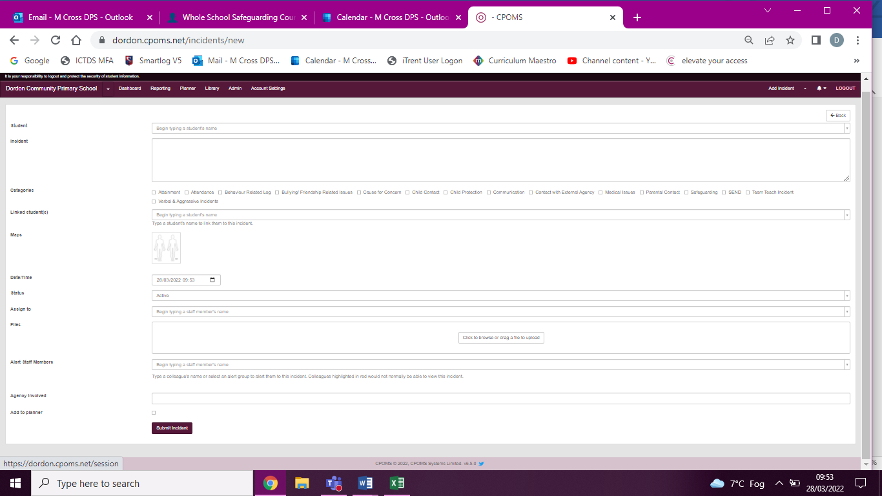When Bullying/ Friendship issues is selected as a category – this is further sub-categorised to enable incidents of homophobic, racist, online bullying, or sexual harassment to be recorded.